EXPERIMENT 1: 8-Queen Problem

Aim: To solve the 8-Queen problem using the Backtracking algorithm.

Objectives:
- To understand the 8-Queen problem.
- To implement the Backtracking algorithm.
- To place eight queens on a chessboard so that no two queens attack each other.
- To find a valid solution efficiently.

Algorithm:
- Start with the first row.
- Place a queen in a safe column.
- Move to the next row.
- If a safe position is found, place the queen.
- If no safe position exists, backtrack to the previous row.
- Repeat until all eight queens are placed.
- Display the solution.

Flow Chart

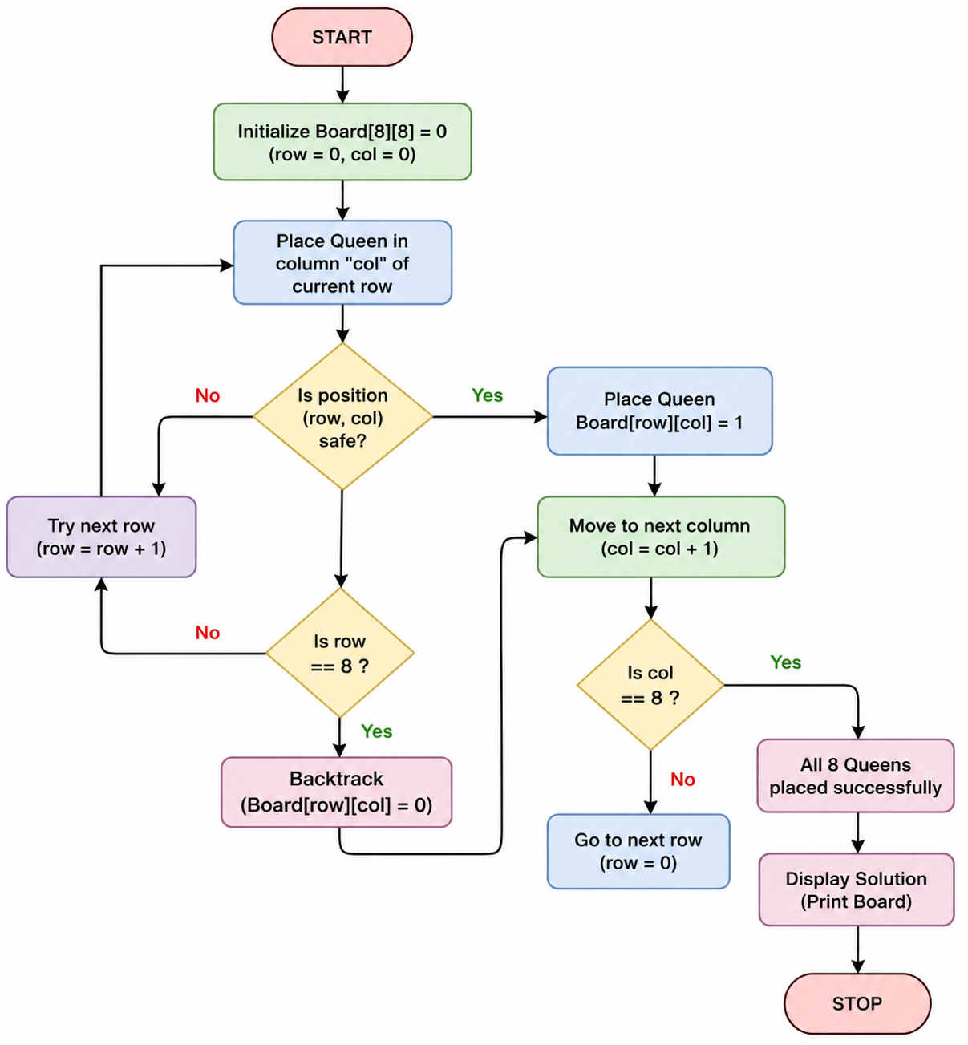

Source Code:
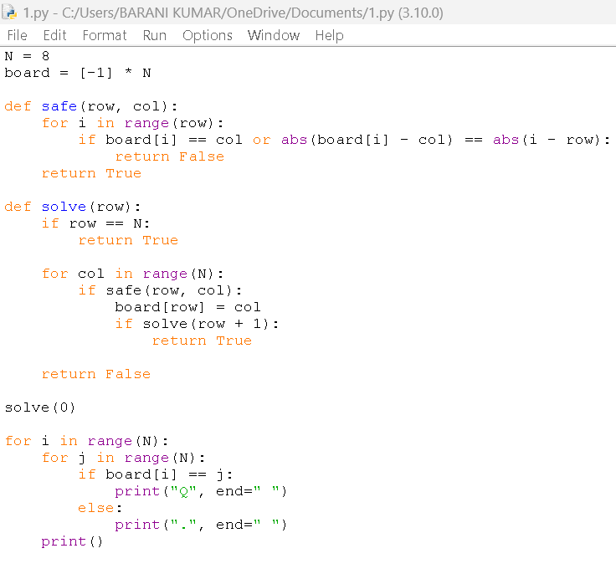

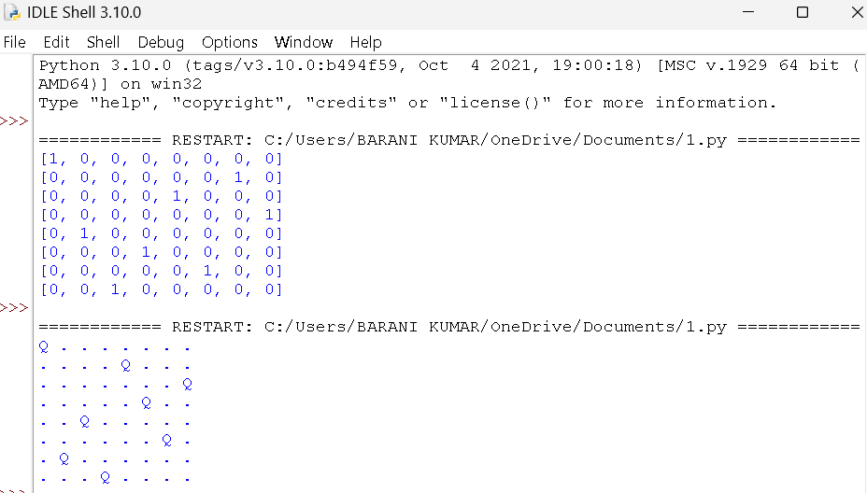
Result:
The 8-Queen problem was successfully solved using the Backtracking algorithm, and all eight queens were placed on the chessboard such that no two queens attack each other.

